- Learning Course Sales and Learner Behavior Analysis Using MySQL

- Project Overview and Objective
This project develops a MySQL-based database system for an online learning platform to manage learners, courses, and purchase transactions efficiently. It stores and organizes data related to course enrollments across different countries and categories. The system enables analysis of learner purchasing behavior, course popularity, and revenue generation. Analytical SQL queries are used to identify top-selling courses, category-wise performance, and learner spending patterns. The main objective is to transform raw purchase data into meaningful business insights that support data-driven decision-making and improve course marketing strategies.

- Data Sources
● Source Description and Timeline:E-Learning Course Sales and Learner Behavior Analysis Using MySQL
● Domain: Customer Support Ticket Management and Analytics

- Problem Statement
Online learning platforms generate large volumes of data related to learners, courses, and purchases. However, without a structured database system, it becomes difficult to track learner activity, analyze sales performance, and identify popular course categories. The platform needs an efficient way to store and manage purchase records while providing meaningful insights into learner behavior and revenue trends. This project aims to design a MySQL-based relational database that organizes e-learning purchase data and supports analytical queries for better business decision-making.

4. Attribute (Column /Features) Details:
Column  Name | Attribute Description | Data Type | Data Category
learner_id | Unique identifier  assigned to each learner | INT | Numerical (Primary Key)
full_name | Name of the learner enrolled  on the platform | VARCHAR | Categorical (Text)
country | Country of the learner | VARCHAR | Categorical
course_id | Unique identifier assigned  to each course | INT | Numerical (Primary Key)
course_name | Name of the course  purchased by learners | VARCHAR | Categorical (Text)
category | Category to which the  course belongs | VARCHAR | Categorical
unit_price | Price of a single course unit | DECIMAL | Numerical (Continuous)
purchase_id | Unique identifier for each  purchase transaction | INT | Numerical (Primary Key)
quantity | Number of course units purchased | INT | Numerical (Discrete)
purchase_date | Date on which the course  was purchased | DATE | Date/Time
total_amount | Total purchase value  (Unit Price × Quantity) | DECIMAL | Numerical (Calculated)

- ExploreTools

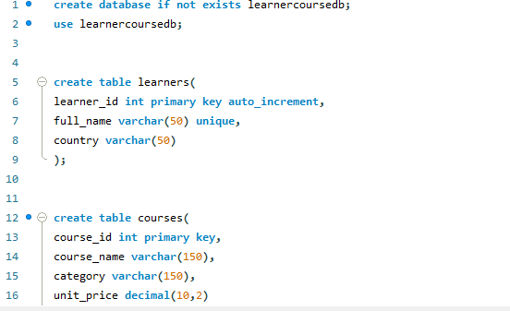

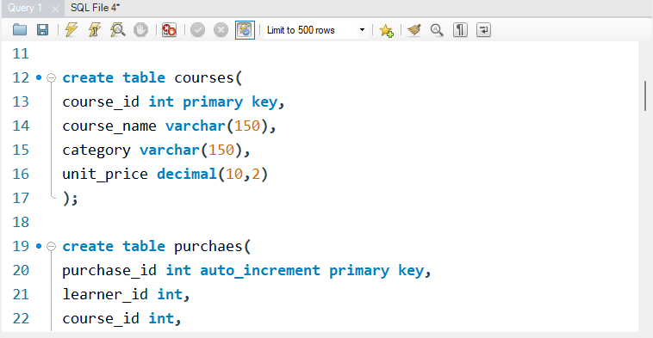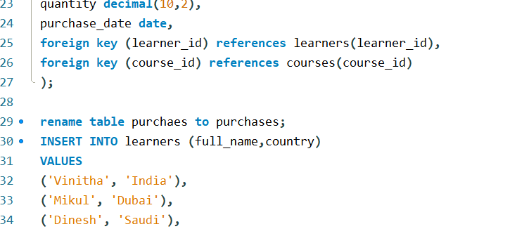

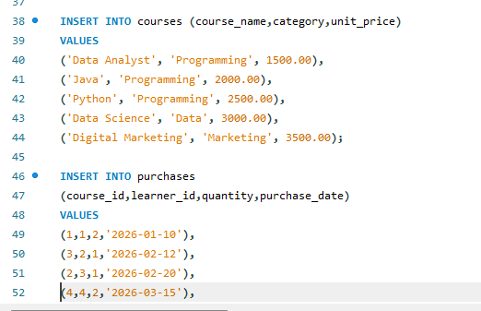

• This script creates a database named learnercoursedb and selects it for use.
• It creates a learners table to store learner details such as ID, name, and country.
• It creates a courses table to maintain course information including category and unit price.
• A purchaes table is created to record course purchases and is later renamed to purchases.
• Foreign key relationships are established between the purchases, learners, and courses tables to maintain data integrity.
• Sample data is inserted into all three tables, enabling analysis of learners, courses, and purchase transactions.

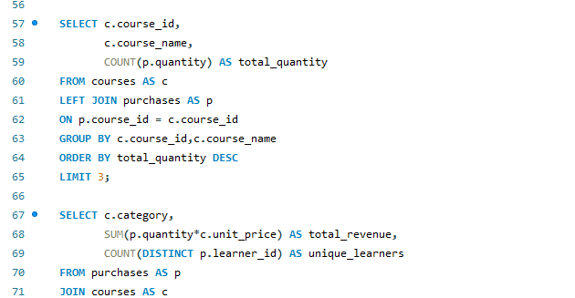

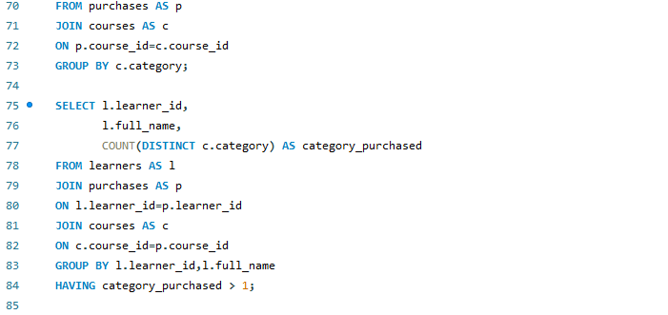

• The first query identifies the top 3 courses based on the total quantity purchased by learners.
• The second query calculates the total revenue and number of unique learners for each course category.
• The third query finds learners who have purchased courses from more than one category.
• The fourth query displays detailed purchase information, including the learner name, course name, unit price, and quantity purchased.
• The fifth query generates a transaction report showing course details, purchase quantity, revenue earned, and purchase date.
• These queries demonstrate the use of JOINs, aggregation functions, GROUP BY, HAVING, ORDER BY, and calculated columns for business analysis and reporting.

- Summarization
Summarizes historical purchase data to show sales performance, learner activity, and course popularity. It helps understand what has happened on the platform. Analyzes purchase patterns and trends to identify reasons behind course demand and revenue performance. It helps explain why certain outcomes occurred.Uses past purchase data to forecast future course enrollments and sales trends. It helps anticipate learner demand and business growth.Recommends actions such as promoting popular courses and targeting specific learners to improve sales. It helps optimize business decisions and increase revenue.

- Conclusion
This project demonstrates how a MySQL-based database can efficiently manage and analyze e-learning purchase data. It helps track learner activities, course sales, and category-wise performance in a structured manner. The analytical queries provide valuable insights into learner behavior, revenue generation, and popular courses. These insights support data-driven decision-making and help improve business strategies. Overall, the system enhances operational efficiency and contributes to the growth of the online learning platform.

